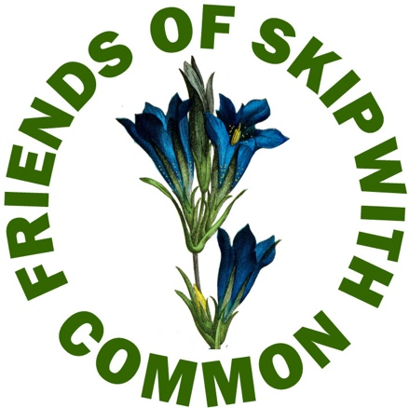 | Annual General Meeting  10 November 2022  Report to Members

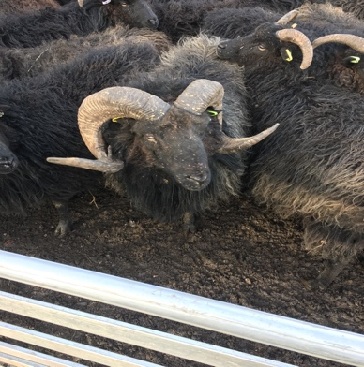 | 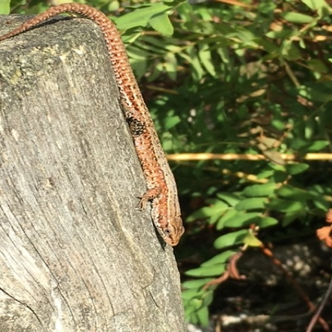 | 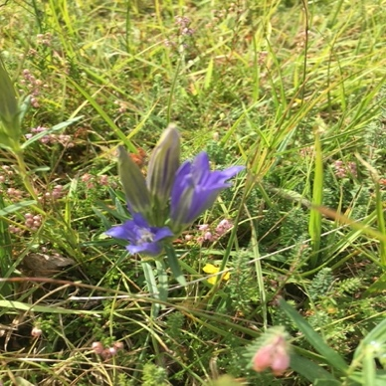

Introduction

After the turmoil of the previous two years, 2021-22 has been a welcome period of relative calm and serenity in the FOSC world. COVID, while ever-present, has gradually receded into the background, enabling a return to near-normal as far as activity on the Common is concerned. While the surge in visitor numbers we saw during lockdown has diminished, many people still come to enjoy the Common’s unique landscape as a peaceful refuge from an increasingly fast-moving and at times bewildering world.

This report updates members on our activities over the past year and looks ahead to 2022-23.

Membership

Membership for the year stood at 46. Many thanks to all members for demonstrating a special interest in and commitment to the Common and supporting the work of preserving the NNR.

New members are always welcome and we hope to increase membership further in the coming year. After many years of subscriptions at £5p.a., the Committee has taken the decision to increase the subscription to £7p.a. As well as contributing to the costs of FoSC’s activities (Events, Tasking, Projects etc), members benefit from free places on our programme of events through the year.

As ever we’d love to hear from members about your ideas for events and activities on the Common and would welcome members who want to become more active in FOSC. There’s a common thread running through this report: if you want to let us know your views, or to become more closely involved please either speak to a Committee member at the AGM or email us at skipcomfriends@gmail.com

FOSC Committee

The Interim Committee of five ceased to be interim at the November 2021 AGM and the Friends’ Committee (Beki Hagger, Terry Heselton, Susie Newton, Sue Thompson and Simon Willis) has continued to meet to plan events, organise the task group and liaise with Escrick Park Estate and Natural England to support their management of the Common.

The Committee continues to run successfully without designated officers (with the exception of our Treasurer, Beki, who keeps the finances on the rails) and we take turns to chair and minute meetings.

The Committee aims to meet roughly every 6 weeks and during 2021-22 the Committee met 8 times. Having learned how during lockdown, we now regularly meet via Zoom/Google Meet.

We really would welcome more members who would like to join the Committee and help run FOSC so if you would be interested, please either speak to a Committee member at the AGM or email us at skipcomfriends@gmail.com

Events

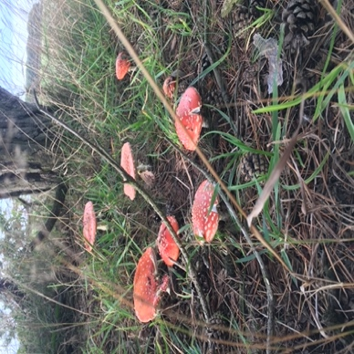 | 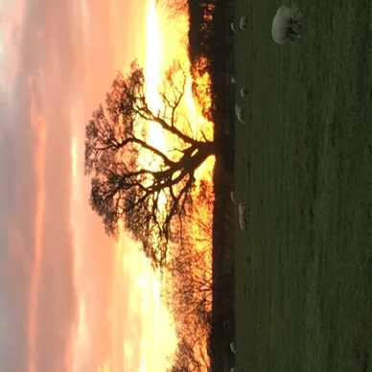 | 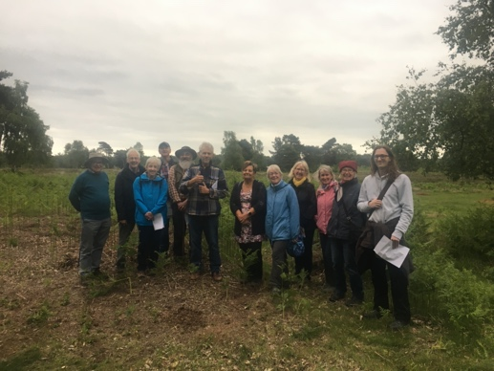

5 events during the year have provided participants with new insights into the history, archaeology and flora and fauna on the Common.

The programme began at the AGM in November 2021 with a fascinating talk from Community Archaeologist Jon Kenny on the dig at the Moated Manor Site opposite Skipwith Church. Jon’s expertise in recreating a vision of the sixteenth century from an unpromising muddy field was truly impressive. The dig has continued through 2022 so we’ll get him back for an update at some point.

March saw our regular Winter Warmer Walk and we are grateful to Jackie Ashcroft for once again leading participants round some of the less well-known parts of the Common. Jackie’s expert knowledge of the byways of the Common (and its lesser-visited nooks and crannies) was greatly appreciated by all those who joined this enjoyable walk.

In April buildings archaeologist Mark Simpson conducted a revealing tour of the St Helen’s Church, Skipwith. Focussing principally on the churchyard, Mark showed us things we would normally not give a second glance to including the medieval grave slabs now used to cap the wall at the front of the church and the Bear stone in the tower, thought to be part of a piece of ecclesiastical furniture. In the church itself, we saw the Ragnarok stone on which is carved a fascinating grafitto depicting a scene from Norse Mythology thought to represent the Apocalypse.

Jon Kenny returned in June to lead a walk exploring the archaeology of the Common. Jon took us on a time travel from the Ice Age to the Second World War, pointing out the many remains left on the Common by successive waves of human habitation. We learned a lot and came to appreciate the importance of the Common to communities stretching back thousands of years.

Finally in October, Michael ‘Ziggy’ Senkans led a full group on our ever-popular Fungi Walk, Mushrooms, Moulds and Miracles. Ziggy was, as usual, both informative and entertaining and we all came away marvelling at the huge variety of fungi to be found in even a small area of the common as well as a new appreciation of the important part fungi play in our ecosystem.

To continue our efforts at community engagement we had a stall again at the Skipwith Fête on 18 June. This traditional village Fete is held in the grounds of Skipwith Hall and raises funds for St Helen’s Church. It proved a good opportunity to explain to the many visitors what FoSC is and what we do. We had a new Treasure Hunt game based on the Common (of course!) and this sparked many questions and 2 new members.

Less successful was our attempt to revive the hogget meal at the Drovers Arms in July. Escrick Park Estate had kindly donated a hogget and the Drovers was all ready to cook it but numbers weren’t enough for a viable event and we had to cancel. We’d welcome hearing from members on this. Is it worth trying again in 2023? Let us know either by speaking to a Committee member at the AGM or emailing us at skipcomfriends@gmail.com
Task Group

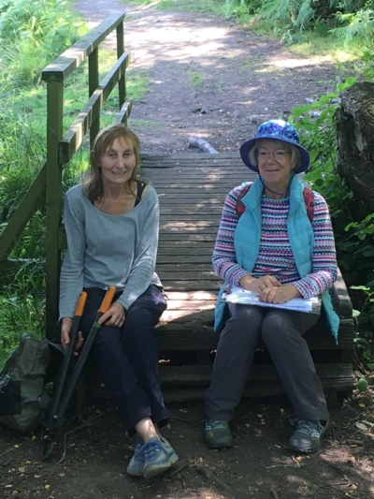 | 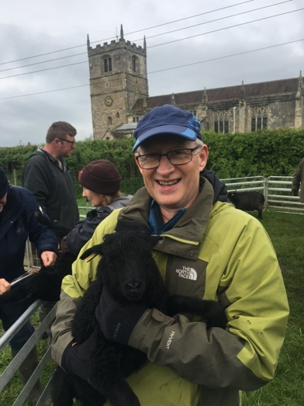 | 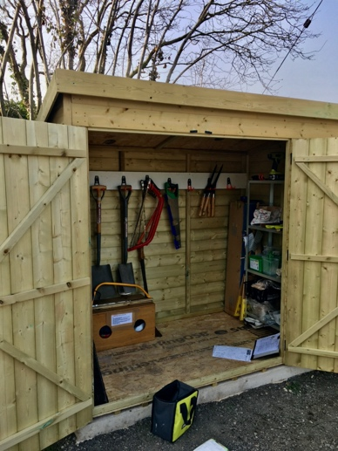

The Friends’ Task Group meets throughout the year, mostly fortnightly and mostly on Wednesdays. We plan a schedule of tasks three-months ahead in discussion with the landowners, Escrick Park Estate (EPE), and Natural England who manage the Common on EPE's behalf to ensure that what we do supports their work in preserving and enhancing the Common’s environment.

Since the last AGM, members of the Task Group have put in just over 400 hours on the Common. Some highlights of the year include:

- work on the infrastructure, mending fences, benches and walkways and replacing waymarker posts;
- the annual survey of the Marsh Gentian population (Gentiana pneumonanthe). The Marsh Gentian occupies a special place in FoSC hearts (see our logo!) so we were pleased to see a small increase in numbers of this beautiful and rare plant;
- clearance of paths and removal of obstructing trees following Storms Dudley and Eunice;
- bagging and destruction of millions of Himalayan Balsam seeds to help prevent its takeover of the Common; and
- assisting the Shepherd, Matthew Taylor, with the flock of Hebridean Sheep.

The work of the Task Group has been greatly helped this year with the arrival of a storage shed located in Skipwith village. We are hugely grateful to Escrick Park Estate for the gift of the shed: we can keep all our tools and materials secure and easily accessible close to the Common.

If you would be interested in joining the Task Group, please do speak to one of the Committee members at the AGM or email us at skipcomfriends@gmail.com.

Projects

We’ve also been working on a couple of projects which don’t quite fit under the headings above:

The Line Ponds
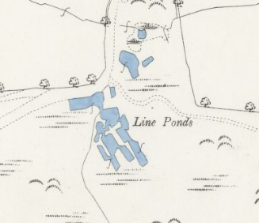
The site of the Line Ponds is on the left as you enter the Common from the Skipwith Village. Little is now left of what would once have been an important working site where villagers retted flax for the linen industry. Retting is a process which uses the action of micro-organisms and moisture on plants to dissolve or rot away much of the cellular tissues surrounding plant fibre bundles facilitating separation of the fibre from the stem.

FoSC is working with Jon Kenny (Community Archaeologist) towards an archaeological investigation of the site following which we may undertake sensitive work on at least one of the line ponds if this is deemed appropriate, removing invasive birch, willow and rush and re-establishing its original profile. We’re currently in the scoping stage and we’ll report further on this as the project develops.

FoSC website and other communications
During 2022, the website (https://friendsofskipwithcommon.org.uk/) has been revamped by Iain at The Cybermill, a local web design company. We’ll make increasing use of the website to keep Members informed and updated so take a look at what’s there and bookmark the site for future reference.

We’re also hoping to use our Facebook page more regularly to keep in touch. This, and the task of keeping the website refreshed, needs skills beyond those of the current Committee (!) and we could do with some help. If this is your area of interest and expertise and you would like to play a role in our communications, please speak to one of the Committee members at the AGM or email us at skipcomfriends@gmail.com.
Looking ahead
Overall, FoSC enters the new year in good shape. The original vision of the Friends as “a group of people who enjoy Skipwith Common and who will work to conserve it for future generations” is alive and well. And as our 25th anniversary in 2024 comes into view, we remember and salute the Founders and all those who have contributed to the group over the years. Since the last AGM we are sad to record the passing of a former FOSC Chairman, John Hilton, in March 2022.
We are delighted to have welcomed so many new members, our programme of Events has been popular and well received and the Task Group is going strong. We continue to work closely with Escrick Park Estate and Natural England and were particularly pleased to meet Mark Hewitt, new Conservation Lead for the Estate. Thanks are also due to Beilby Forbes Adam (Escrick Park Estate) and Craig Ralston and Fallon Mahon (Natural England) who have been very supportive of our work.

From the report above we’re sure you have got the message, however, that on all fronts we could do with more actively involved members. It doesn’t require a big commitment of time and there are several ways you can be involved without actually joining the Committee (though you’d be welcome). So - for the last time! -

If you’d like to become more involved with the Friends please speak to one of the Committee members at the AGM or email us at skipcomfriends@gmail.com

FOSC Constitution

